JPO 152 Additional Physics
Class Test 3A : 3 May 2013
Surname: Student Number: Total: /20
Question 1 [9]
The diagram below depicts a block sliding along a frictionless surface from A to C. After that the block crosses a horizontal section CD where it experiences a frictional force and comes to a stop at D.
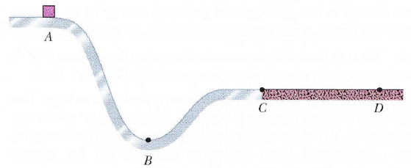
- Is the block’s mechanical energy increasing, decreasing or remaining constant in region AC? Explain (3)
Remains constant. Since the floor is frictionless in this case then there are only conservative forces acting on the block and thus by the conservation of mechanical energy principal the mechanical energy is constant

- Is the block’s mechanical energy increasing, decreasing or remaining constant in region CD? Explain (3)
Decreasing. Since friction is present then then the conservation of mechanical energy no longer applies. By conservation of total energy $∆E=0⇒∆E_{mech}+∆E_{th}=0$ and since $∆E_{th}=f_{k}d>0$ then $∆E_{mech}<0$.

- If the height between A and B increases will the distance CD increase, decrease or remain the same? Explain (3)
Remain same. $∆E_{mech}$ is a constant value between A and C and increasing height will only temporarily increase potential energy. Hence since position C is still at same point then kinetic energy at C will be the same. Hence speed it reaches friction area with remains the same and thus stopping distance will also remain the same
Question 2 [4]
Below are four graphs of position versus time for two bodies and their centre of mass in different situations. The two bodies form a closed, isolated system and undergo a completely inelastic, one dimensional collision on an x axis. Which graphs correspond to a physically impossible situation? Explain
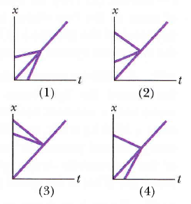
2 and 3. In a closed and isolated system the centre of mass must be between the two object and must undergo no changes in its velocity. This means that middle graph must be the centre of mass and in order to be physically possible this line cannot have a change in gradient when the two objects collide (which happens in 2 and 3)

Question 3 [7]
A 3.50 g bullet is fired horizontally at two blocks at rest on a frictionless table. The bullet passes through block 1 (mass 1.20 kg) and embeds itself in block 2 (mass 1.80 kg). The blocks end up with speeds $v_{1}=0.630 m/s$and $v_{2}=1.40 m/s$.
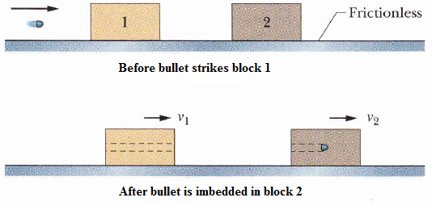
If the amount of material displaced from block 1 by the bullet is negligible then find:
- The speed of the bullet as it enters block 2 (3)
We apply momentum conservation to relate the situation just before the bullet strikes the second block to the situation where the bullet is embedded within the block.
$$P_{i}=P_{f}$$
$$0.0035v=1.8035\left(1.4\right)⇒v=\frac{1.8035\left(1.4\right)}{0.0035}=721m/s$$

- The speed of the bullet as it enters block 1 (4)
Again conservation of linear momentum applies but now the speed at which the bullet enters block 2 is the same as the speed at which the bullet leaves block 1
$$P_{i}=P_{f}$$
$$0.0035v=1.2\left(0.630\right)+0.0035\left(721\right)⇒v=\frac{1.2\left(0.630\right)+0.0035\left(721\right)}{0.0035}=937m/s$$

Formula Sheet
$$W_{net}=∆E_{k}$$
$$F=-\frac{dE_{p}}{dx}$$
$$W=∆E_{mech}+{∆E}_{th}+∆E_{int}$$
$${\vec{r}}_{com}=\frac{1}{M}\sum{m_{i}{\vec{r}}_{i}^{2}}$$
${\vec{F}}_{net}=M{\vec{a}}_{com}$ ${\vec{F}}_{net}=\frac{d\vec{P}}{dt}$
$$\vec{J}=\int_{t_{i}}^{t_{f}}{\vec{F}\left(t\right)dt}$$

